Examples of Coal Authority data holdings

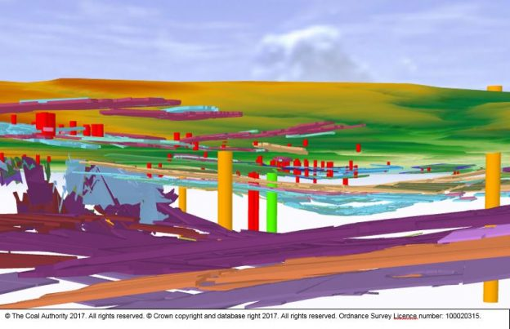

Bilston Glen 3D visualisation using digitised mine data

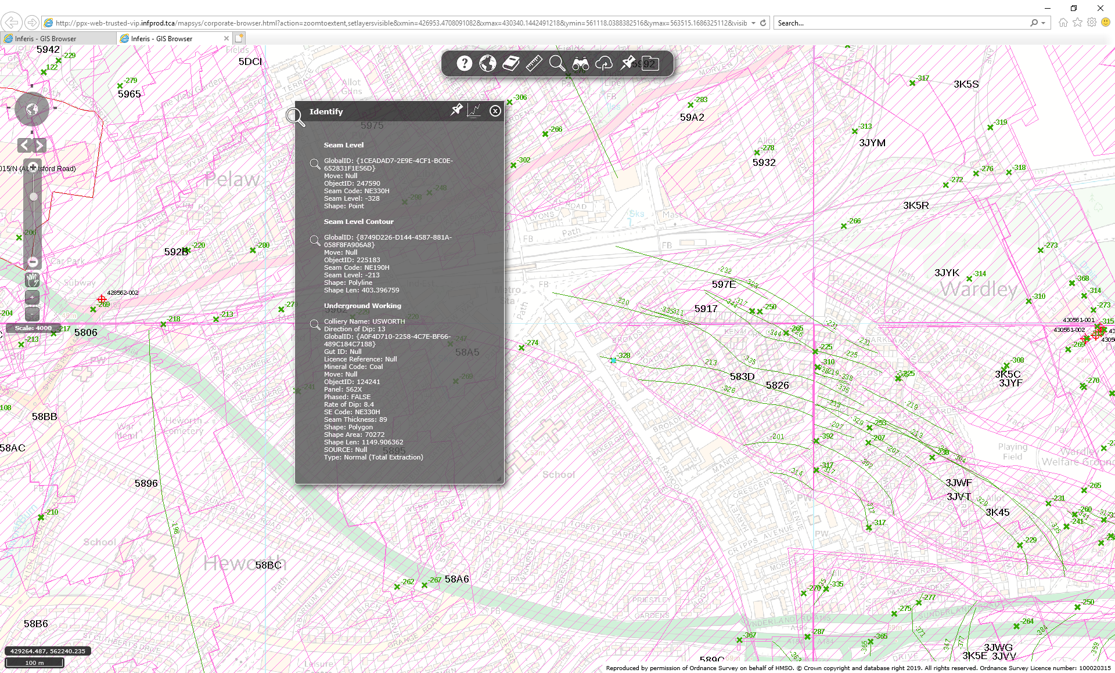

Example of underground workings polygons with seam levels and contours (multiple seams are distinguished using seam codes)

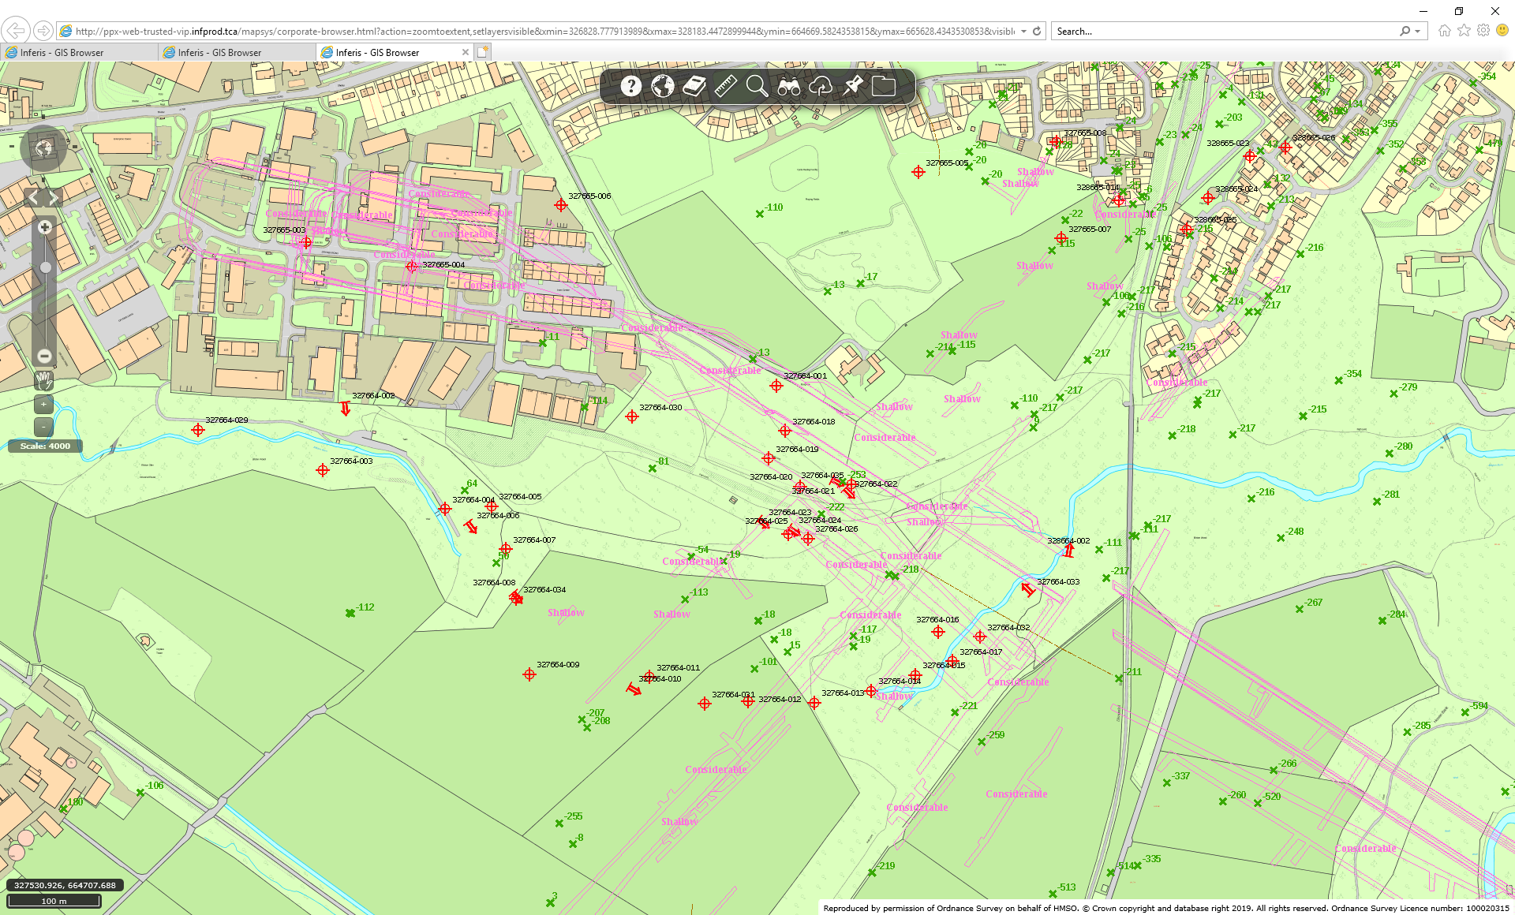

Bilston glen pit bottom roadways

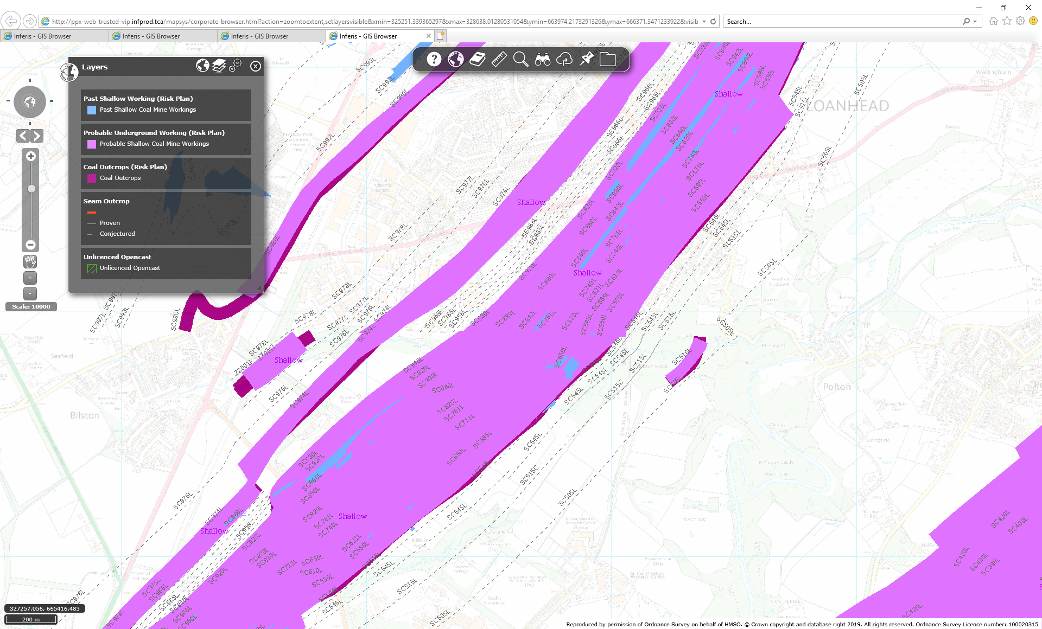

Possible way to visualise where groundwater recharge is likely to workings – using shallow coal workings / outcrop layers

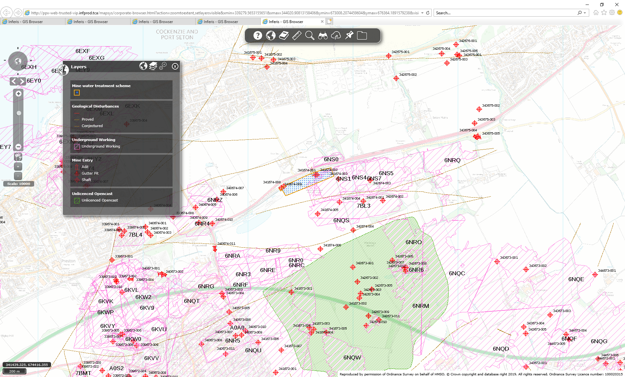

Blindwells site – opencast, some deeper workings polygons, and some east west dykes

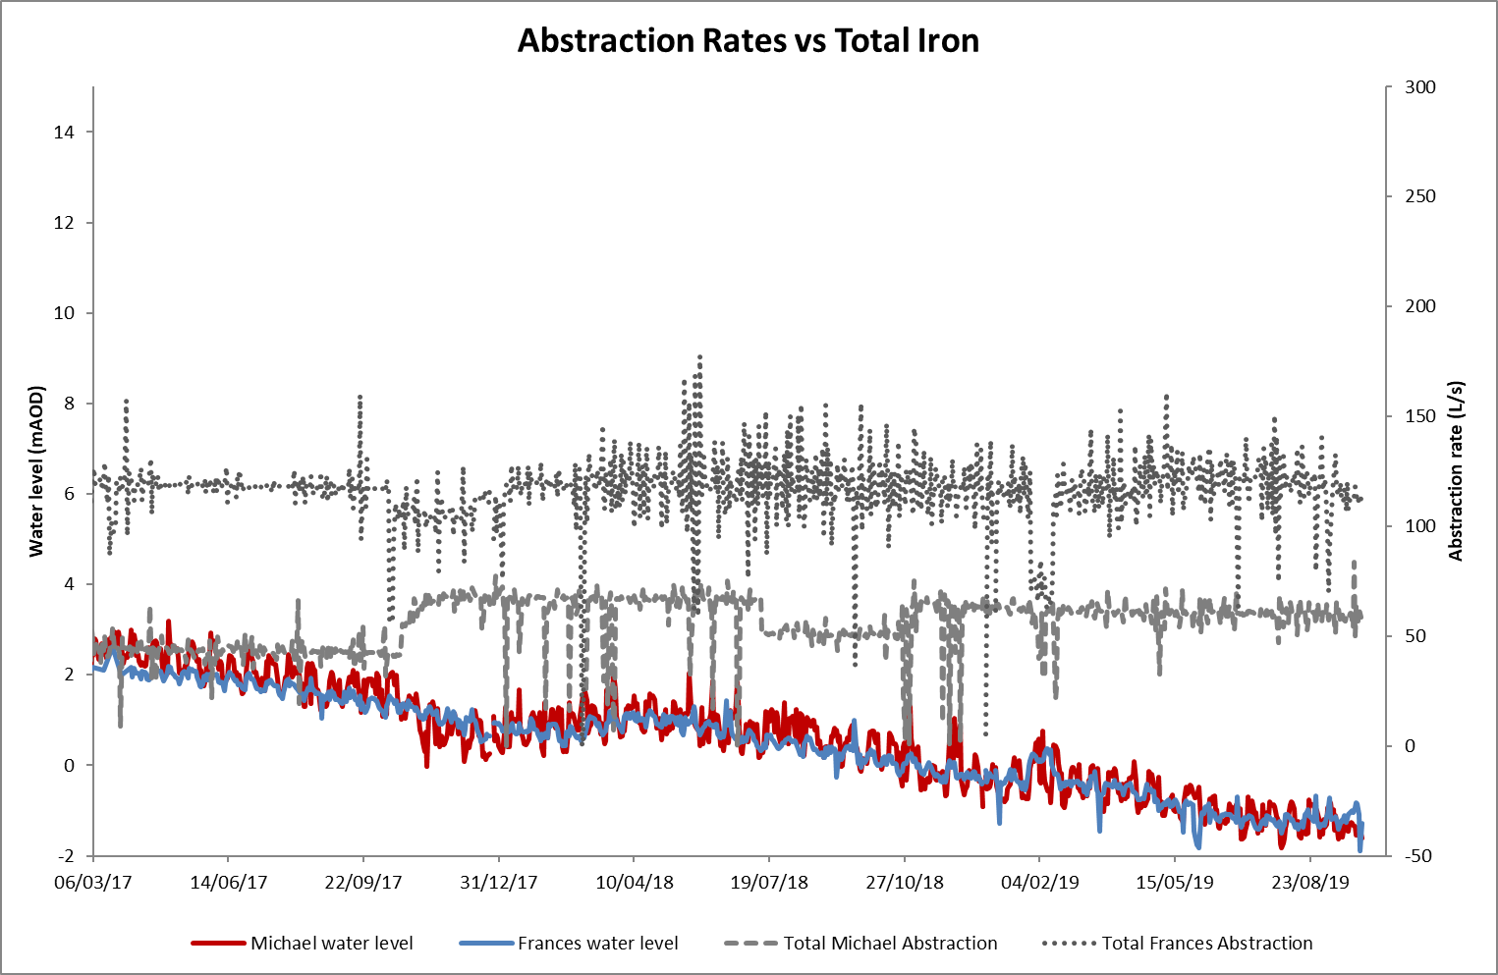

Michael pumping test data – flow vs water level; temperature data is available for ~3 years at different flow rates